Denial of Access with UAV Anti-Drones
  - Written by Cody Hatfield

Abstract
Since their introduction, surveillance has been a staple of use cases for remote Unmanned Aerial Vehicles (UAVs). They provide a relatively cheap and easy means for those with even very little piloting experience to maneuver an optical device remotely through the air across large distances, especially in comparison to a full commercial helicopter. This has lead to the deployment of UAVs for everything from wedding photography to land surveyors to artillery strikes. This last scenario has been widespread during the as yet ongoing Russo-Ukrainian War, where it is typical for both sides to each have on average between 25 and 50 surveillance platforms active in any particular 10 km frontage of combat [1]. To give a scale of how common their usage has become, researchers have estimated that as many as 10,000 Ukrainian drones are lost every month in the conflict [1], while the Russians are consistently using multiple UAVs to provide situational awareness for assault squads as well as to coordinate artillery barrages [1]. The ability to deny geographic access of these UAVs would thus be of tactical advantage, however there would also be applications beyond the battlefield. Of particular note is the defense of refugee camps and civilian leaders from drone based terrorist attacks, such as the one that was carried out during a parade in the 2018 Caracas drone attack [2]. Sensitive installations may also need protection from the prying eyes of a drone, even if the intent behind the incursion is not deadly, and drone usage by drug cartels along the southern border of the US have only become more frequent as the years wear on [3].
There are some existing systems which can deny unauthorized UAVs access to designated spatial zones. The missile stopping C-RAM has been saving lives all throughout the Iraq war [4], and is more than qualified in fulfilling this role. However, platforms like the C-RAM, or its close counterpart the CWIS, are notoriously expensive, both to implement and to maintain. To successfully operate these systems requires the use of highly trained personnel who also require substantial surrounding infrastructure to support their operations. A system with a lower cost would be desirable, especially if it could be deployed and used by the lay-person.
Drones have already proven to satisfy these requirements in the realm of optical surveillance. The creation of “anti-drones” would be an effective choice for Denial of Access roles, preferably such that the platform is re-usable and more sophisticated than simply strapping C4 to the frame and then detonating it in mid-flight near unauthorized UAVs. As such, we will use this document to propose an abstracted anti-drone based Denial of Access framework as well as test scenarios to demonstrate the efficacy of this approach.
The intent is for our UAV Raptor to fly towards unauthorized UAVs and then use the actuator to disable them. Some variations of this scenario will be presented, but the shared goal among them all is this ability to damage the UAVs to such a degree that they are rendered inoperable. The absence of any friendly humans is assumed, however we recognize that cooperative deployments of UAV Raptors alongside friendly security forces represents an exciting possibility for future research.

Entities

- Drone (Agent) – UAV Raptor
  - Our framework will assume a basic quad-copter design with outer body dimensions no larger than a meter.
  - Will be mounted with an actuator that launches small projectiles via a pneumatic action, much like a paintball gun.
- Target – Unauthorized UAV
  - Similarly sized to the UAV Raptor.
  - May be hovering, patrolling, or evading.
  - May have explosive charges attached, but otherwise no weaponry assumed.
- Munition Actuator
  - Projectile is launched via pneumatic action. Pneumatic was chosen primarily because it offers very low recoil which could destabilize the drone. However, it is also a cheap and plentiful means of propulsion that is available for most workshops.
  - Other actions such as the High-Low Propulsion System may be possible for those with access to more sophisticated technology.
- Raptor Munition
  - The munition projectile which is launched from the UAV Raptor.
  - Projectile will travel some pre-determined distance before it detonates and expels shrapnel around itself.
  - This distance is built into the munition hardware, and is not changed at runtime.

Environment
The environment will consist of open skies. Gusts of wind may occur. There will be no obstacle avoidance to consider outside of avoiding the target drone. All flight will be assumed to occur between 20 meters and 200 meters of altitude. While there will likely be benefits for developing anti-drone behaviors in crowded urban environments, these will be explored in future work. Similarly, this scenario will only focus on targeting a single drone at this time.

Visualization
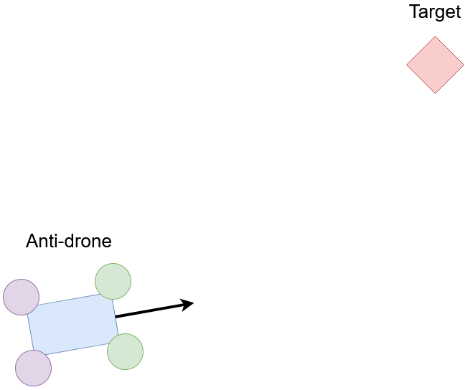

State Space
- Drone (Agent) – UAV Raptor
  - Step ID: Z
  - Position: R³ = [ x, y, z ]
  - Forward Direction: R³ = [ x, y, z ] (unit)
  - Velocity Direction: R³ = [ x’, y’, z’ ] (unit)
  - Speed: R
  - Angular Velocity: R³ = [ pitch’, roll’, yaw’ ], (world space)
  - Motor RPMs: R⁺⁴ = [ front_right, front_left, back_right, back_left ]
  - Actuator Signal: B
  - Target Direction: R³ = [ x, y, z ] (unit)
  - Target Distance: R
  - Target Velocity Direction: R³ = [ x’, y’, z’ ]
  - Target Speed: R
  - Target Hit: B
    - Target Hit is technically future information.
    - When a projectile is fired, and it hits the target, the state which issued the actuator signal will have this value set to True, as well as all states after.
    - Initialized to False.
  - Projectile ID: Z
    - The PyBullet simulation ID number of the projectile which was fired.
    - Value is None if no projectile was fired at this state instance.
- Target – Unauthorized Drone
  - Position: R³ = [ x, y, z ]
  - Rather than simulate a fully functional drone, the target will be a simple non-dynamic entity which is moved around via script.
- Projectile
  - Position: R³ = [ x, y, z ]
  - Velocity: R³ = [ x’, y’, z’ ]
  - Projectile Radius = R
    - The radius of all objects affected by the projectile’s explosion.
  - Step ID: Z
    - The step ID at which the projectile was fired.

Action Space
- Drone (Agent) – UAV Raptor
  - Motor RPMs: R⁺⁴ = [ front_right, front_left, back_right, back_left ]
  - Projectile Actuator: B

Start States
- Drone (Agent) – UAV Raptor
  - Position: The agent will spawn within a given set of positions
  - Angle: The agent will spawn within a given set of angles
  - Velocity: The agent will spawn within a given set of velocities
  - Angular Velocity: The agent will spawn within a given set of angular velocities
  - Actuator Signal: The agent will spawn with an actuator signal given
  - Target: The agent will spawn with a particular target
  - Target Hit: Initialized to False
- Target – Unauthorized Drone
  - Position: The target will spawn within a given set of positions
  - Angle: The target will spawn within a given set of angles
  - Velocity: The target will spawn within a given set of velocities
  - Angular Velocity: The target will spawn within a given set of angular velocities

Goal State
- Drone (Agent) – UAV Raptor
  - Target Hit: True

Reward Map
- Actuator Activation
  - Reward is scaled based on the closest distance the projectile has with the target.
  - Negative reward if closest distance is above a threshold
  - Positive reward if closest distance is below threshold.
  - 0 Reward if at the threshold.
  - All states where Target Hit is True all receive the positive reward.
- Altitude
  - Negative reward if altitude is not within a given set.
- Target Distance
  - Negative reward if distance to the target is too small.

Scenario Variations
- Static Target
  - Target is placed in a static position, and never moves.
- Patrol Target
  - Target moves between a set of waypoints which form a complete cycle.
  - Bob up and down
  - Move side to side
  - Move in a circle
- Zig-Zag Target
  - Target only moves forward in a zig-zag maneuver
  - Randomness in zig and/or zag length can be selected.

References
[1] https://static.rusi.org/403-SR-Russian-Tactics-web-final.pdf
[2] https://www.bbc.com/news/world-latin-america-45073385
[3] https://www.cbsnews.com/news/drug-cartels-more-bomb-dropping-drones-mexico-army/
[4] https://web.archive.org/web/20091231120809/http://defense-update.com/newscast/0508/news/news2105_c_ram.htm

